Proof of Work: the Cost Function of Hard Money
I was inspired to write this after reading Nic Carter’s The Last Word on Bitcoin’s Energy Consumption [1]. His work is pretty rigorous, and it won’t benefit anyone for me to echo what he’s already said, so this is my own take on the energy usage question, and the value I see in bitcoin as a proof of work-derived cryptocurrency. As a relative newcomer to bitcoin my theory is still developing, and feedback is welcome.
Cost Function
What does the energy expenditure represent within the context of Bitcoin’s proof of work (PoW) algorithm? Quite simply it is the cost of truth. It is the price that is paid for Bitcoin’s immutability; for the veracity of its ledger, or blockchain. I assert here that energy spent on proof of work is definitively not waste. The energy spent on proof of work is a sunk cost for hard money. It is quite obviously what gives bitcoin its value. The proof of work cost function is essentially a transfer of value, in converting electrical energy over here into an approximately equal value in bitcoin over there (plus some profit margin, for your troubles). The energy is not wasted, but converted into a wholly unrecognizable form.
This can be shown by examining the opposite case. For, if it were to cost nothing to add a block to Bitcoin’s blockchain, then anyone would do it. Anyone, including unscrupulous miners or thieves. The cost for them to make spurious claims as to their account balances would be very nearly $0. Not good! Bitcoin would collapse under the weight of a million dubious claims to it. It is no accident that the Bitcoin protocol emerged out of a technology meant to thwart denial of service attacks (see: Adam Back’s Hashcash [2]). Bitcoin is the Hashcash-inspired, money plus Captcha; resistant to scammers and spammers, and anybody that would seek to extract value from it in exchange for nothing. Indeed, proof of work is precisely what confers durability and hardness to bitcoin as a money.
Hashrate and Security
I think this is what is meant when people describe a strong hashrate as providing “security” for the network. Where the price of mining a block is much less than the present value of the PoW cryptocurrency, then there will be an incentive to mine illegitimate blocks, to perpetrate a double-spend attack in order to steal. The soundness of the money would crack, and its value would disintegrate. While destructive, this strategy may prove lucrative in the short run. However, where there is healthy competition in mining, and mining is relatively expensive, then the economic cost for dishonest mining becomes great. I believe this is the essence of several points that Hal Finney made, stating [approximately] that “mining should be expensive” and that “mining should not be too profitable.” Since, if mining were too profitable, it would imply that the mining difficulty is very low, and that the network is easily gamed. Anecdotally this is what is seen where it is possible to cheaply spin up a lot of hashpower and point it at “softer” SHA-256 blockchains like BCH, BSV — they become susceptible to 51% attacks. Conversely, if a cryptocurrency is unprofitable in the long-term, you will expect the uneconomical miners to disconnect from the network. Anyway, with Bitcoin’s capability to adjust its difficulty, a natural price equilibrium emerges that is a balance of three things: hashrate value (as in $/TH; see hashrateindex.com), profit, and the costs of mining (capital costs + energy cost + operating expenses). Too much profit leads to more competition, higher total hashrate, and a difficulty adjustment upwards. Zero or negative profit causes unprofitable miners to leave, and difficulty to eventually adjust downwards. Ultimately, part of Satoshi’s genius is in designing a near-perfect economic control loop that converges on a profitable — but not too profitable — method of corroborating the ledger of their nascent financial network. It is a necessary and defining feature, and incredibly, it just freaking works!
Waste vs. Cost
So what do I say to people that think that Bitcoin’s energy consumption is wasteful? To put it simply, no. As a highbrow ass: it is the economically-efficient price [the cost function] for hard money. If there were no proof of work, and there was no economic cost, then anybody could write to the blockchain, and bitcoin would be fiat. It’s value would evaporate [or need to be enforced by a government]. Bitcoin is not fiat; it has some natural value more like a commodity, or property; a digital tangible. Although you cannot physically touch it, bitcoin is absolutely real. And unlike dollars, they are not synthesized out of thin air at zero cost. It can be excused for thinking this is the case for bitcoin, since electricity is often generated outside of population centers, in centralized power plants. But mining bitcoin does in fact require physical “work” in both the sociological, and energy sense. Ultimately, the cost of the energy expended on the network is the primary compensatory vehicle to which bitcoin’s value is ascribed. As shown above, the resources consumed establish the value of the Bitcoin network, and are therefore, not wasted.
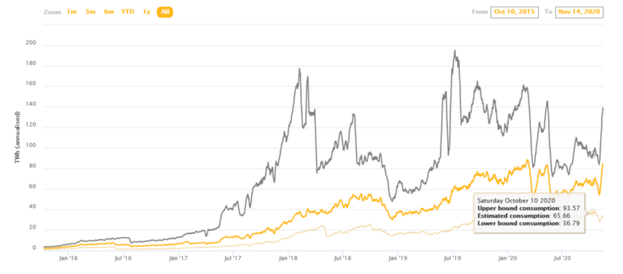Figure: Snapshot from Cambridge Bitcoin Electricity Consumption Index
Bitcoin and the Environment
Many people balk at the sizeable energy usage of the Bitcoin network, which is currently estimated between 8–10 gigawatts. To provide contrast, I present a more philosophical argument that is hard to measure, but most certainly true. My charge is against the alternative to bitcoin; the astronomically greater ecological cost of synthetic economic growth, that is a direct result of unsound money. Idea in brief: in a world of extremely low interest rates, unprofitable projects were made to look profitable, and demand was “pulled in” from the future. This scheme decisively worked in putting TV sets in families’ living rooms, and steadily pushing GDP up and to the right. It also led to trillions of single-occupant-commuter miles driven, terawatts of coal-fired power plants built, and hundred of billions of tons of concrete poured. Human beings systematically converted to ravenous consumers, and now, effectively live in a house that we can’t afford (See: The Price of Tomorrow [3]). All in the name of manufactured growth. This was made possible by grinding inflation, loose credit, and low interest rates. In other words free, unsound money. So here I propose that money should have a cost, and let us present the current plight of our planet and economy as proof of what happens when it does not. Unsound money is the problem, proof of work is one possible answer. I am not saying it is the only answer, but at the current time, it seems to be a damn good one.
Parting Thoughts
I am decidedly a dabbler in many things, and bitcoin is one of them. While I’d like to think this article is directionally correct, I reserve the right to be totally wrong, and to flip-flop later. It is the privilege of “strong convictions, loosely held.” So, for expert testimony I highly recommend reading these other pieces, probably better than the one you’re reading, that inspired my thinking below:
- Nic Carter: The Last Word on Bitcoin’s Energy Consumption
- Adam Back: Hashcash — A Denial of Service Counter-Measure
- Jeff Booth: The Price of Tomorrow
- Leo Zhang: The Alchemy of Hashpower (parts I and II)
- Satoshi Nakamoto: Bitcoin: A Peer-to-Peer Electronic Cash System

